Task Description
Work Order Status
Purpose:
The purpose of reviewing workorders in SYSPRO is to ensure each work order has the correct parts.
Procedure:
- Sign into SYSPRO Company A for BWS or SYSPRO Company S for Stargate.
  - Under work order status, click on work orders status report.
BWS Manufacturing – SYSPRO Company A | Stargate – SYSPRO Company S
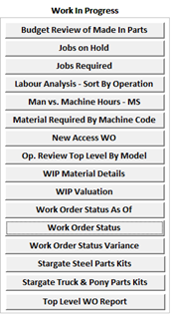 | 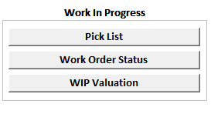

BWS Manufacturing
  - Input workorder number.
  - Click run report.
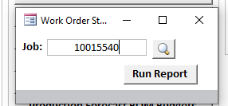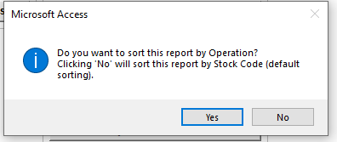
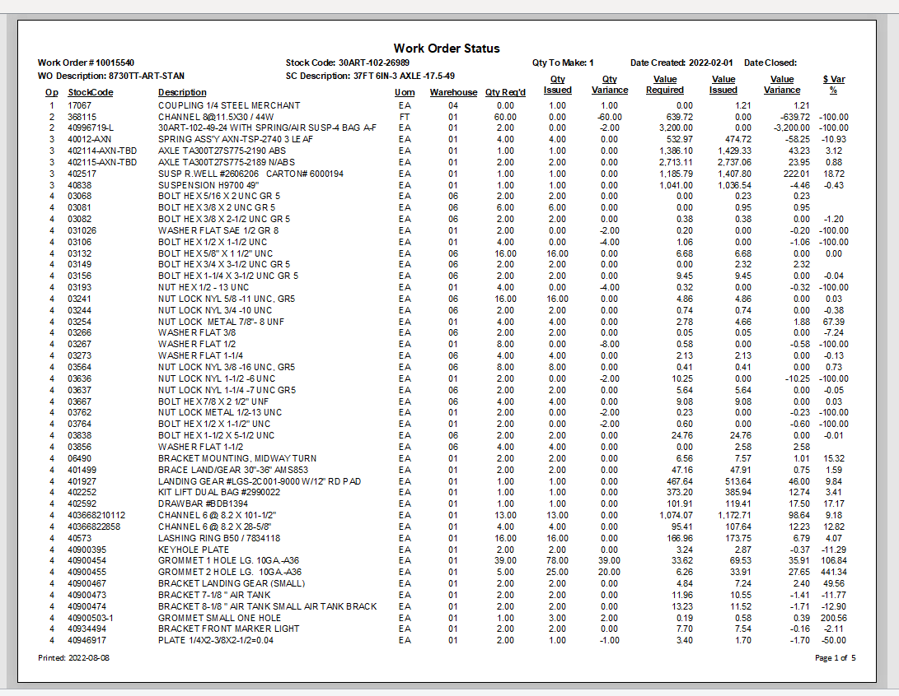
Part number.
Operation the part is required for.
Stocking unit of measure.
Item description in short.

Qty then Eng./BOM believe the workorder required.
Default warehouse.

Difference between the amount that was predicted for the unit and what was used.
Qty manufacturing have used to the workorder.

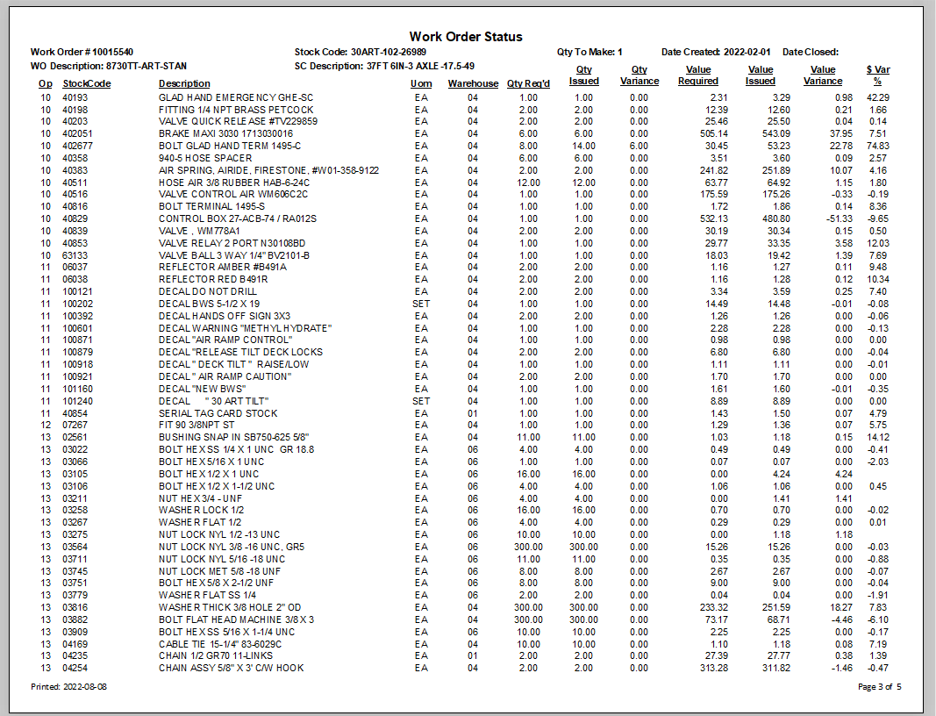
Dollar value required (when part was added on).
Dollar value issued (when part was added on).

Difference between money $$ required and issued.

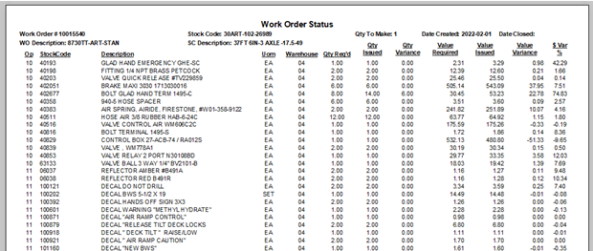
This shows the cost difference

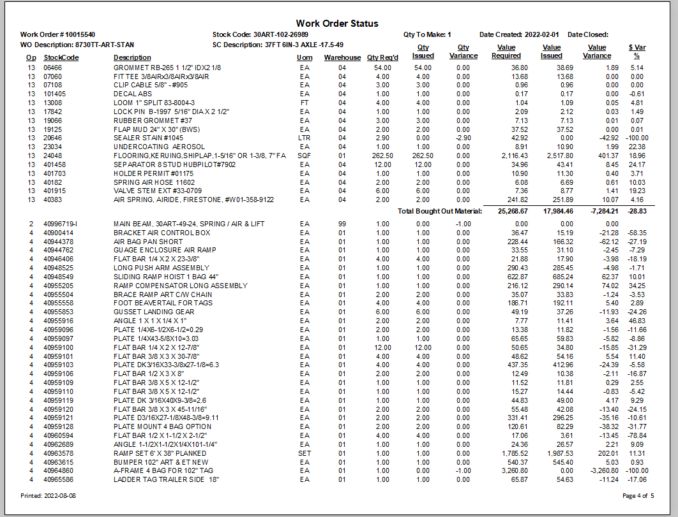
Report is divided into bought out, made in, subcontract and labor cost $$.
This is the bought-out subtotal.

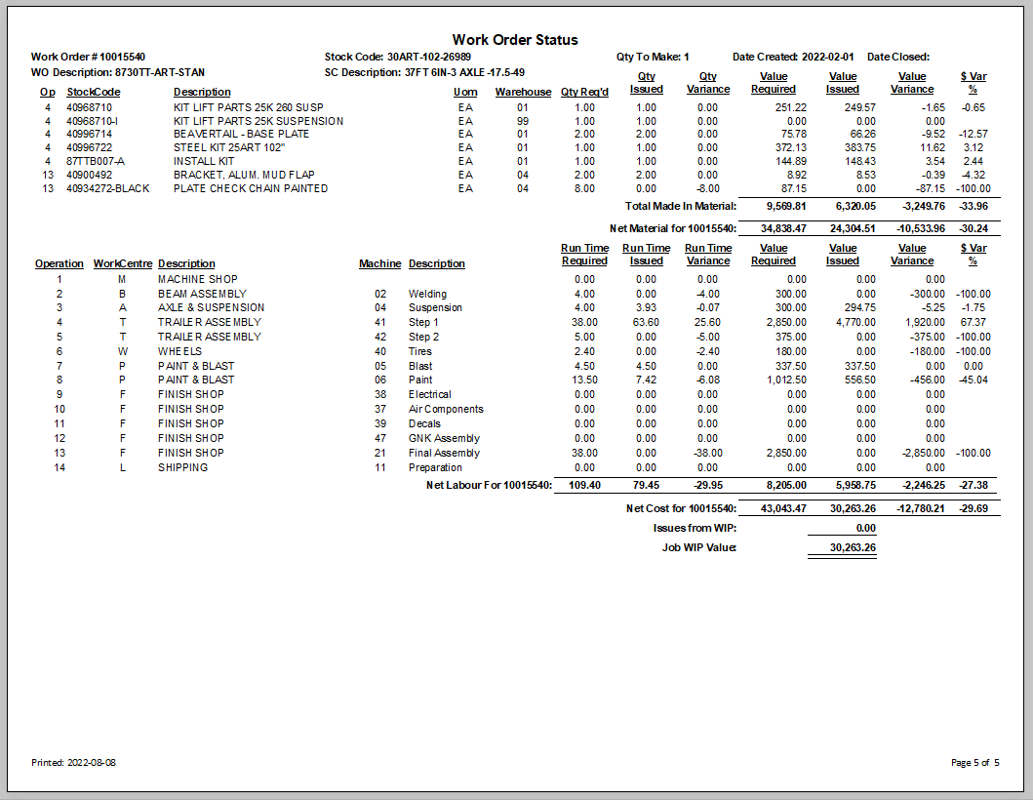
Work order number.
This is the stock code being made by this work order.
Description of the stock code being made.

Date the work order was first made.
Date the work order was closed. If blank I is still open and in process.
Made in subtotal.
Material, sub total bought out, made in, sub contact.
Value of labor required, issued, the variance and the % over and under.

Work center description
Work center
Operation #
# of hours required
# of hours used to date.
Difference of hours.
Total value of work order to date.

